USER MANAGEMENT

# Purpose

The User Management module functions to manage the information of readers and users of LIB system.

# Usage

To open “User Management” module, user must select button “User Management” in the tab “Main Page”.

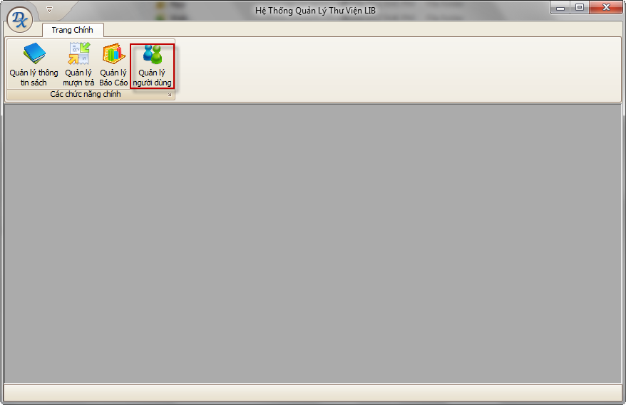

# Main Interface

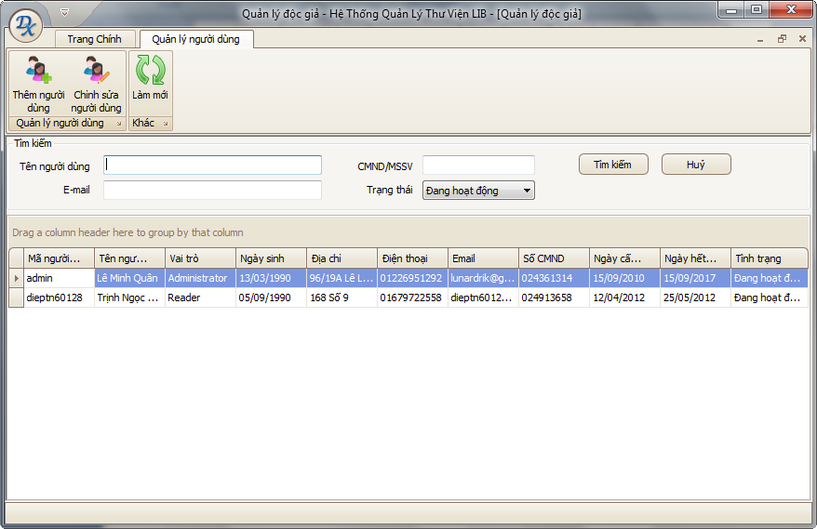

# Main Functions

## Add User

Purpose

This function is used to add a new user into the system. The added users may be librarians or readers but not Administrator.

Usage

* Click button “Add User”.
* A dialog will appear with the following information  
  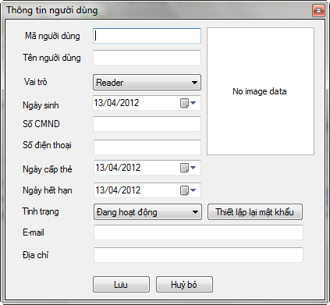
* Users must enter complete information in the dialog box. If any information is invalid, the system will display the message specific.
* Click "Save" to save the reader information, "Cancel" to cancel operation.

Effect

After the user selects "Save" button, the system will perform the following operations

* A new reader is inserted into database.
* A new record is added to the current list.

## Edit User

Purpose

This function allows the user to edit information is included in the system. The edited users can be librarians or readers but not administrator.

Usage

* Double-click a user in the list below or select a user in the list below, then click "Edit User".
* A dialog box will appear.  
  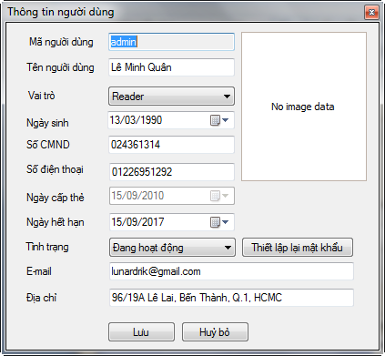
* Users must enter complete information in the dialog box. If any information is invalid, the system will display the message specific.
* Click "Save" to save the reader information, "Cancel" to cancel operation.

Effect

After the user selects "Save" button, the system will perform the following operations:

* The new user information is saved to the database and be displayed on the current user list.